1)WAP to check whether a no. is odd or even

//WAP to check whether odd or even
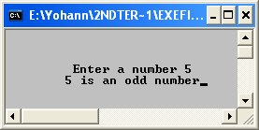
#include <iostream.h>
#include <conio.h>
main()
{
clrscr();
int a,b,c;
cout<<"\n\n\n\t Enter a number ";
cin>>a;
if(a%2==0)
cout<<a<<"\t is an even number";
else
cout<<a<<"\t is an odd number";
getch();
}

2) WAP to print the greatest number

//WAP to Print The Greatest Number
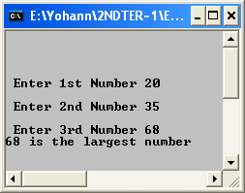
#include <iostream.h>
#include <conio.h>
main()
{
clrscr();
int a,b,c;
cout<<"\n\n\n\n Enter 1st Number";
cin>>a;
cout<<"\n Enter 2nd Number";
cin>>b;
cout<<"\n Enter 3rd Number";
cin>>c;
if(a>b&&a>c)
cout<<a<<" is the largest number";
else if(b>a&&b>c)
cout<<b<<" is the largest number";
else
cout<<c<<" is the largest number";
getch();
}

3) WAP to read two numbers and an Operater and print desired result

//WAP to read two numbers and an Operater and print desired result
#include <iostream.h>
#include <conio.h>
main()
{
clrscr();
float a,b;
char c;
cout<<"\n\n\n\n Enter 1st Number ";
cin>>a;
cout<<"\n Enter 2nd Number ";
cin>>b;
cout<<"Enter a operater ";
cin>>c;
if(c=='+')
cout<<"\n Addition is equal to "<<a+b;
else if(c=='-')
cout<<"\n Subtraction is equal to "<<a-b;
else if(c=='*')
cout<<"\n Multiplication is equal to "<<a*b;
else if(c=='/')
cout<<"\n Division is equal to "<<a/b;
else
cout<<"Invalid Operater entered";
getch();
}

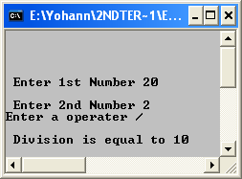

4) WAP to read age and check right to vote

// WAP to read age and check right to vote
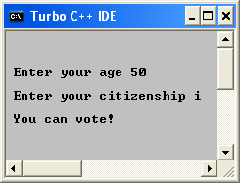
#include <iostream.h>
#include <conio.h>
main()
{
clrscr();
int ag;
char c;
cout<<"\n\n\n Enter your age ";
cin>>ag;
cout<<"\n Enter your citizenship ";
cin>>c;
if(ag>=18 && (c=='I'|| c=='i'))
cout<<"\t\n You can vote!";
else
cout<<"\t\n You cannot vote!";
getch();
}

5) WAP to check whether year is a leap year

// WAP to check whether year is a leap year
#include <iostream.h>
#include <conio.h>
main()
{
clrscr();
int yr;
cout<<"\n\t Enter the year ";

cin>>yr;
if(yr%4==0)
cout<<"It is a leap year";
else
cout<<"It is not a leap year";
getch();
}

6)WAP to ask a no. If odd print square, else print cube.

//WAP to ask a no. If odd print square, else print cube.
#include <iostream.h>
#include <conio.h>
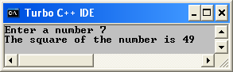
main()
{
clrscr();
int a;
cout<<"Enter a number ";
cin>>a;
if (a%2==0)
cout<<"The cube of the number is "<<a*a*a;
else
cout<<"The square of the number is "<<a*a;
getch();
}

7) WAP TO CALCULATE AREA OF CIRCLE, RECTANGLE,TRIANGLE OR SQUARE
//WAP TO CALCULATE AREA OF CIRCLE, RECTANGLE,TRIANGLE OR SQUARE
#include <iostream.h>
#include <conio.h>
main()
{
clrscr();
char a;
float ar;
cout<<"What figure do you want";
cin>>a;
if (a=='c')
{
float rad;
cout<<"Enter radius ";
cin>>rad;
ar=rad*rad*(22.0/7.0);
cout<<"Area is "<<ar;
}
else if(a=='r')
{
float len,brd;
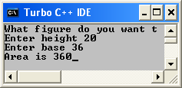
cout<<"Enter Length ";
cin>>len;
cout<<"Enter breadth ";
cin>>brd;
ar=len*brd;
cout<<"Area is "<<ar;
}
else if(a=='t')
{
float bas,ht;
cout<<"Enter height ";
cin>>ht;
cout<<"Enter base ";
cin>>bas;
ar=bas*ht*(1.0/2.0);
cout<<"Area is "<<ar;
}
else if(a=='s')
{
float sid;
cout<<"Enter side ";
cin>>sid;
ar=sid*sid;
cout<<"Area is "<<ar;
}
else
cout<<"Choice invalid ";
getch();
}

8) WAP to check if it is a vowel or not

// WAP to check if it is a vowel or not
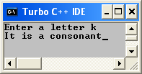
#include <iostream.h>
#include <conio.h>
main()
{
clrscr();
char vc;
cout<<"Enter a letter ";
cin>>vc;
if (vc=='a'||vc=='e'||vc=='i'||vc=='o'||vc=='u')
cout<<"It is a vowel";
else
cout<<"It is a consonant";
getch();
}

9) WAP to print roots of a quadratic equation

//WAP to print roots of a quadratic equation
#include<conio.h>
#include<iostream.h>
#include<math.h>
main()
{
clrscr();
float r1, r2, des, desrt;
int a,b,c;
cout<<"\n\n\nEnter value of a in ax*x+bx+c ";
cin>>a;
cout<<"\n\nEnter value of b in ax*x+bx+c ";
cin>>b;
cout<<"\n\nEnter value of c in ax*x+bx+c ";
cin>>c;
des=(b*b)-(4*a*c);
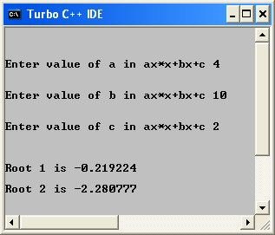
if(des>=0)
{
desrt=sqrt(des);
r1=(-b+desrt)/(2*a);
r2=(-b-desrt)/(2*a);
cout<<"\n\n\nRoot 1 is "<<r1;
cout<<"\n\nRoot 2 is "<<r2;
}
else if (des<0)
{
des=des*(-1);
desrt=sqrt(des);
r1=(-b+desrt)/(2*a);
r2=(-b-desrt)/(2*a);
cout<<"\n\n\nRoot 1 is "<<r1;
cout<<"\n\nRoot 2 is "<<r2;
}

getch();
}

10)WAP to give the day on the basis of number inserted
//WAP to give the day on the basis of number inserted
#include<iostream.h>
#include<conio.h>
main()
{
clrscr();
int a;
cout<<"Enter a ";
cin>>a;
switch(a)
{
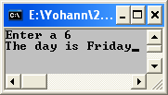
case 1:
cout<<"The day is Sunday";
break;
case 2:
cout<<"The day is Monday";
break;
case 3:
cout<<"The day is Tuesday";
break;
case 4:
cout<<"The day is Wednesday";
break;
case 5:
cout<<"The day is Thursday";
break;
case 6:
cout<<"The day is Friday";
break;
case 7:
cout<<"The day is Saturday";
break;
default:
cout<<"Wrong Choice";
}
getch();
}

